PROJECT TITLE:

**SOCIAL DISTANCING ALERTING SYSTEM**

INTRODUCTION:

2.1 OVERVIEW

Coronavirus disease (COVID-19) is an infectious disease caused by a newly discovered coronavirus.Most people infected with the COVID-19 virus will experience mild to moderate respiratory illness and recover without requiring special treatment. Older people, and those with underlying medical problems like cardiovascular disease, diabetes, chronic respiratory disease, and cancer are more likely to develop serious illness.The best way to prevent and slow down transmission is be well informed about the COVID-19 virus, the disease it causes and how it spreads. Protect yourself and others from infection by washing your hands or using an alcohol based rub frequently and not touching your face.

2.2PURPOSE

The main purpose of this project is to show us how much people is maintaining social distance among themselves.When two or more people are standing close to each other they can be alerted with this system and the concerned guard or authorities can tell them to maintain distance.

RESULTS: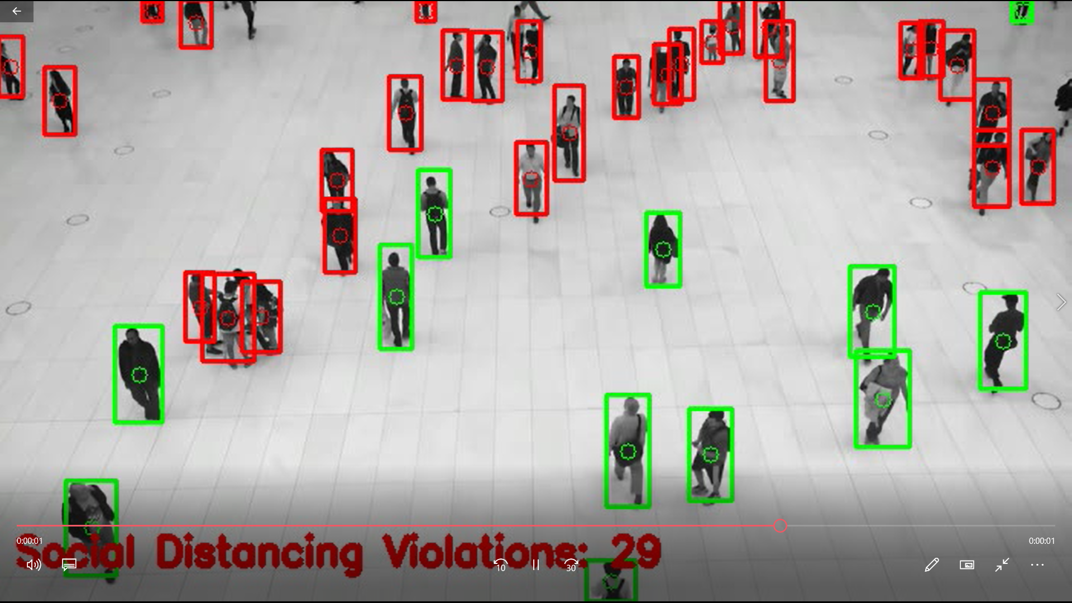

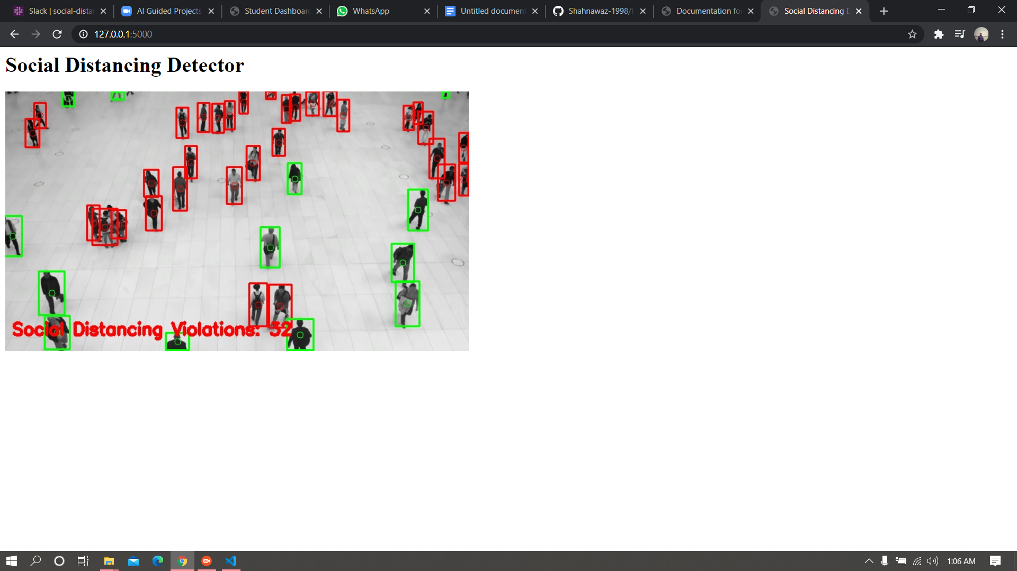

I tried using <http://127.0.0.1:5000/> as <http://0.0.0.0:5000/> was not working.

APPLICATIONS:

This following alerting system can be implemented in various places like:

* Office buildings, Schools, Hospitals.
* Warehouses, Manufacturing areas.
* Airports, Railway stations, Entries and exits.
* Shopping areas, food courts and restaurants.
* Retail.

CONCLUSION:

This system can be easily deployed in the places where there is a lot of crowd.It can help the people to maintain social distance during the pandemic time.Hence by implementing this alerting system we can safeguard work places and working environments.

FUTURE SCOPE:

* Reduce the number of infections and transmissions.
* Safe guard work-spaces and working environment.
* Improve business operational efficiency & productivity.
* Adherence to social-distancing & protection compliance.
* Reduce queuing at public and private business entrances.
* Better decision making through analytics and visualization.
* Real-time global visibility for enterprises.